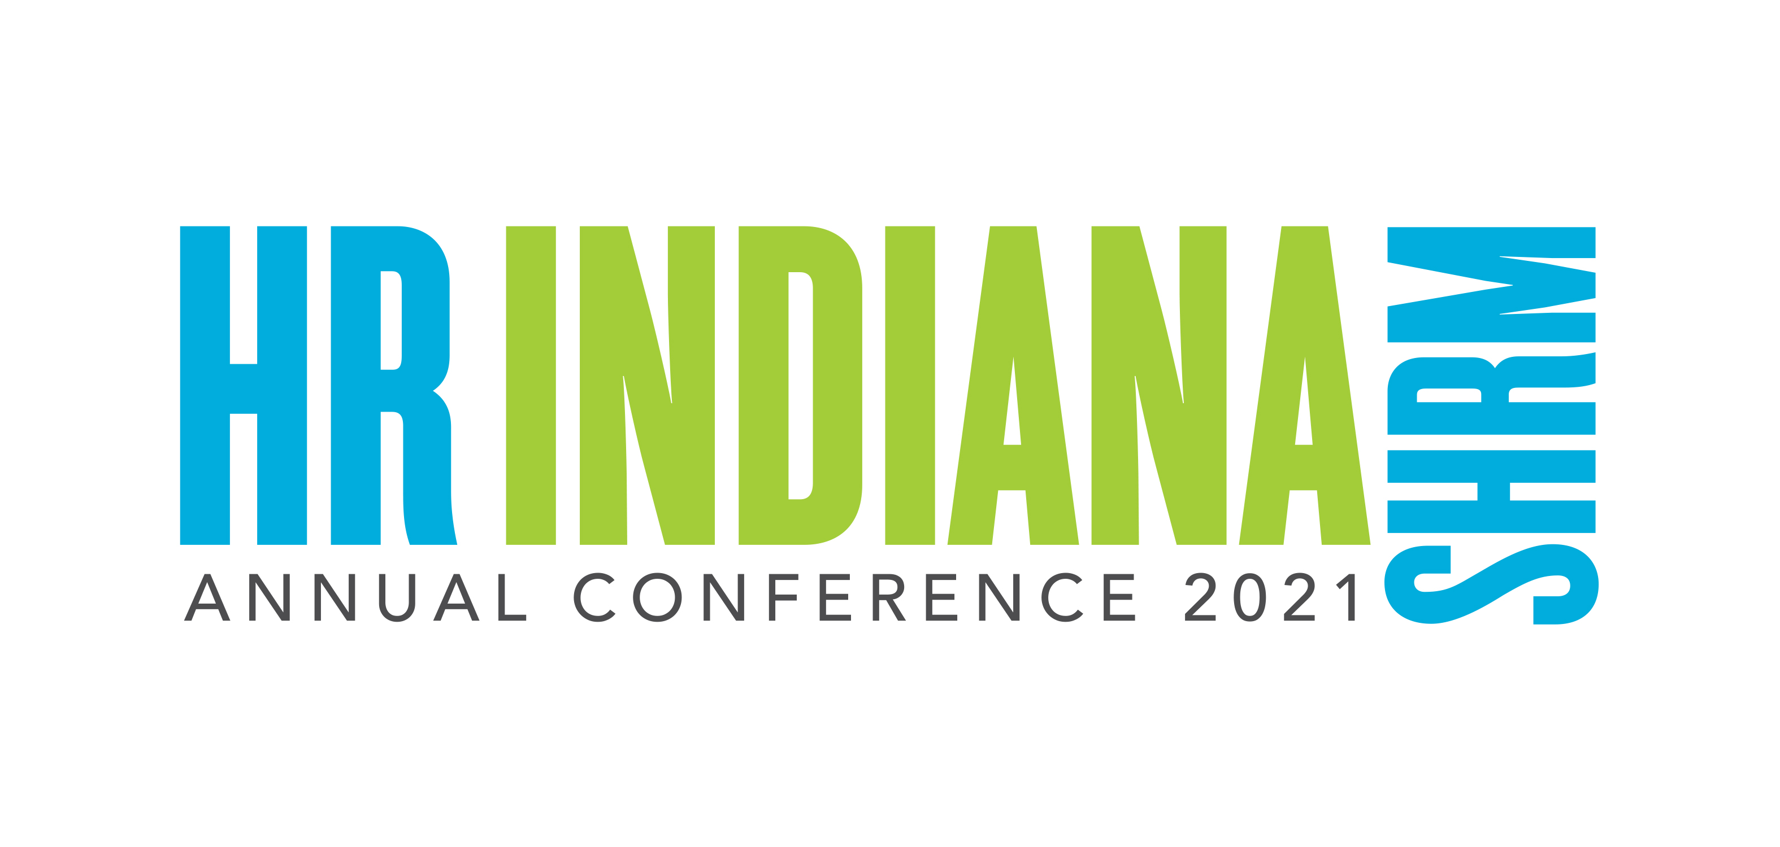
Dear

The SHRM Annual Conference & Expo is the one of the largest state conferences for HR professionals. For education, networking, and professional development, this event simply has no equal. I believe my participation is critical to bringing new ideas and approaches to our organization and further my professional development. I would like to request approval to attend.
The event is August 2-4 in Indianapolis, IN. I’ll be amongst thousands of industry professionals to hear HR experts and innovators talk about employment law and legislation, strategic management, leadership development, global HR, and more. I’ll gain practical skills pertaining to compensation and benefits, talent management, and inclusion and diversity practices. The expo offers the opportunity to network with businesses that could have a positive impact on our organization. By meeting with industry partners, I can find solutions to everyday issues as well as strengthen existing relationships.

I plan to attend the following sessions to strengthen my professional development:

Following are the Exhibitors that I plan to speak with that I think can help our organization.

Here are the costs associated with attending the SHRM Annual Conference & Expo:
Airfare:
Hotel:
Registration Fee:
Miscellaneous (meals/taxi):

This investment will pay off in more efficient practices, proven solutions, new insights and ideas. In addition, I can provide a report of my key takeaways and recommended actions to our team.

I appreciate your approval. I will work to make sure we get the full value of this event. Sincerely,

